**Ex 10 KERNEL INSTALLATION**

**Date: 17.11.20**

**Aim:**

To study and implement the kernel installation .

**Description:**

**Kernel Space:**

Here, the Linux Kernel exists which can be further divided into three levels. At the top is the system call interface, which implements the basic functions such as read and write. Below the system call interface is the kernel code, which can be more accurately defined as the architecture-independent kernel code. This code is common to all of the processor architectures supported by Linux. Below this is the architecture-dependent code, which forms what is more commonly called a BSP (Board Support Package). This code serves as the processor and platform-specific code for the given architecture.

|  |  |  |  |
| --- | --- | --- | --- |
| **Sl.No.** | **Command Name** | **Meaning** | **Description** |
| **1** | **rpm -qa kernel-devel** | It displays the version of the kernel. | Kernel-devel - This package provides kernel headers and makes files sufficient to build modules against the kernel package. |
| **2** | **uname –r** | uname displays the information about the system. | The command ‘uname‘ displays the information about the system.  **option :**  **-a** It prints all the system information in the following order: Kernel name, network node hostname, kernel release date, kernel version, machine hardware name, hardware platform, operating system  -**s** It prints the kernel name.  **-n** It prints the hostname of the network node -r It prints the kernel release date  **-v** It prints the version of the current kernel |
| **3** | **tar** | tar stands for tape archive, is used to create Archive and extract the Archive files | **tar** command in Linux is one of the important commands which provides archiving functionality in Linux. We can use Linux tar command to create compressed or uncompressed Archive files and also maintain and modify them. **Options:**  -c : Creates Archive  -x : Extract the archive  -f : creates archive with given filename  -t : displays or lists files in archive file  -u : archives and adds to an existing archive file  -v : Displays Verbose Information  -A : Concatenates the archive files  -z : zip, tells tar command that create tar file using gzip  -j : filter archive tar file using tbzip  -W : Verify a archive file  -r : update or add file or directory in already existed .tar file |
| **4** | **ln** | A symbolic link, also known as a symlink or soft link, is a special type of file that points to another file or directory. | There are two types of links in Linux/UNIX systems: 1. Hard links 2. Soft links |

**Exercise**

**Step 1 :**

Building kernel and its modules.

**Step 2 :**

Check the current kernel version and name of the kernel.

**Output:**

Moving the kernel to /usr/src



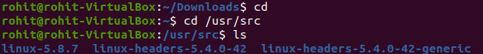

Cleaning the kernel using make



System link to existing kernel



Making target files

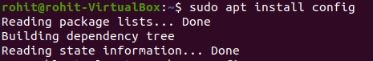

New kernel proof



**Results:**

The kernel installation is studied and executed.

**Video :**

**https:** **https://youtu.be/3RHHZtOz9WE**